МІНІСТЕРСТВО ОСВІТИ І НАУКИ, молоді та спорту УКРАЇНИ
НАЦІОНАЛЬНИЙ ТЕХНІЧНИЙ УНІВЕРСИТЕТ УКРАЇНИ
«КИЇВСЬКИЙ ПОЛІТЕХНІЧНИЙ ІНСТИТУТ»

Факультет прикладної математики
Кафедра спеціалізованих комп’ютерних систем

Лабораторна робота № 3

З дисципліни «Моделювання»

Виконали: Степанюк Михайло
Група КВ-92
Федай Ганна
Група КВ-91

Перевірив Наливайчук М.В.

Київ 2012
Лабораторна робота №3.
"Моделювання клітинкових автоматів"
- Ознайомитися з програмою Life в Matlab
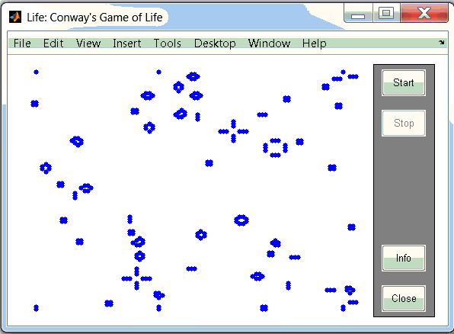
- Вивчити роботу програми Conway's life
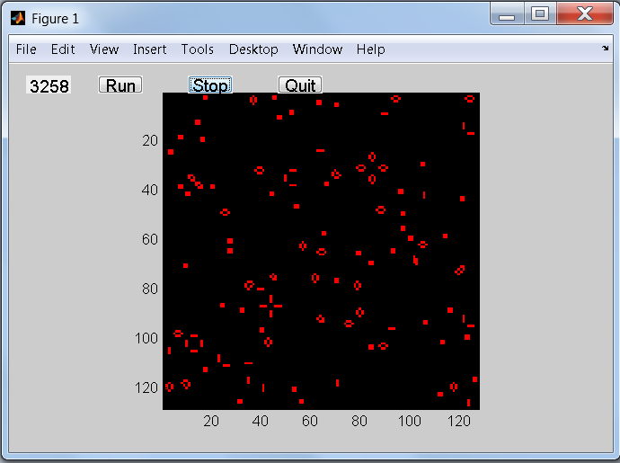
3. Для “хаотичної” вихідної конфігурації, в якій кожна клітинка знаходиться у стані 1 з випадковістю 50% розглянути часову еволюцію правил.
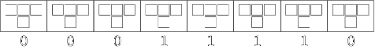
правило 00010010 (правило 18),
0 0 0 1 0 0 1 0

clf
clear all

%=============================================
%build the GUI
%define the plot button
plotbutton=uicontrol('style','pushbutton',...
'string','Run', ...
'fontsize',12, ...
'position',[100,400,50,20], ...
'callback', 'run=1;');

%define the stop button
erasebutton=uicontrol('style','pushbutton',...
'string','Stop', ...
'fontsize',12, ...
'position',[200,400,50,20], ...
'callback','freeze=1;');

%define the Quit button
quitbutton=uicontrol('style','pushbutton',...
'string','Quit', ...
'fontsize',12, ...
'position',[300,400,50,20], ...
'callback','stop=1;close;');

number = uicontrol('style','text', ...
'string','1', ...
'fontsize',12, ...
'position',[20,400,50,20]);

n=32;
%initialize the arrays
z = zeros(n,n);
cells = z;
sum = z;
%set a few cells to one
cells(1,1:n) = rand(1,n)<.5;
%how long for each case to stability or simple oscillators

%build an image and display it
imh = image(cat(3,cells,cells,cells));
set(imh, 'erasemode', 'none')
axis equal
axis tight

%index definition for cell update
x = 2:n;
y = 2:n;

%Main event loop
stop= 0; %wait for a quit button push
run = 0; %wait for a draw
freeze = 0; %wait for a freeze
stepnumber = str2num(get(number,'string'));
while (stepnumber<993)

if (run==1)
for x=2:n
%nearest neighbor sum
sum(x,1) = cells(x-1, 2) + cells(x-1,n) ;
cells(x,1) = (sum(x,1)==1) & (cells(1,1)==0);
set(imh, 'cdata', cat(3,cells,cells,cells) )
%update the step number diaplay
stepnumber = 1 + str2num(get(number,'string'));
set(number,'string',num2str(stepnumber));
for y=2:(n-1)
sum(x,y) = cells(x-1, y-1) + cells(x-1,y+1) ;
% The CA rule
cells(x,y) = (sum(x,y)==1) & (cells(x-1,y)==0);
%draw the new image
set(imh, 'cdata', cat(3,cells,cells,cells) )
%update the step number diaplay
stepnumber = 1 + str2num(get(number,'string'));
set(number,'string',num2str(stepnumber))
end
sum(x,n) = cells(x-1, n-1) + cells(x-1,1) ;
cells(x,n) = (sum(x,n)==1) & (cells(1,n)==0);
set(imh, 'cdata', cat(3,cells,cells,cells) )
%update the step number diaplay
stepnumber = 1 + str2num(get(number,'string'));
set(number,'string',num2str(stepnumber));

end
end

if (freeze==1)
run = 0;
freeze = 0;
end

drawnow %need this in the loop for controls to work

end
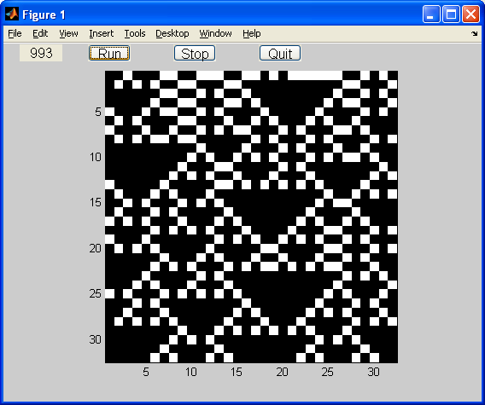

правило 01001001 (правила 73)

0 1 0 0 1 0 0 1
clf
clear all

%=============================================
%build the GUI
%define the plot button
plotbutton=uicontrol('style','pushbutton',...
'string','Run', ...
'fontsize',12, ...
'position',[100,400,50,20], ...
'callback', 'run=1;');

%define the stop button
erasebutton=uicontrol('style','pushbutton',...
'string','Stop', ...
'fontsize',12, ...
'position',[200,400,50,20], ...
'callback','freeze=1;');

%define the Quit button
quitbutton=uicontrol('style','pushbutton',...
'string','Quit', ...
'fontsize',12, ...
'position',[300,400,50,20], ...
'callback','stop=1;close;');

number = uicontrol('style','text', ...
'string','1', ...
'fontsize',12, ...
'position',[20,400,50,20]);

%=============================================
%CA setup
n=32;
%initialize the arrays
z = zeros(n,n);
cells = z;
sum = z;
%set a few cells to one
cells(1,1:n) = rand(1,n)<.5;
%how long for each case to stability or simple oscillators
%build an image and display it
imh = image(cat(3,cells,cells,cells));
set(imh, 'erasemode', 'none')
axis equal
axis tight

%index definition for cell update
x = 2:n;
y = 2:n;

%Main event loop
stop= 0; %wait for a quit button push
run = 0; %wait for a draw
freeze = 0; %wait for a freeze
stepnumber = str2num(get(number,'string'));
while (stepnumber<993)

if (run==1)
for x=2:n
%nearest neighbor sum
sum(x,1) = cells(x-1, 2) + cells(x-1,n) ;
cells(x,1) = ((sum(x,1)==1) & (cells(1,1)==1)) | ((sum(x,1)==0) & (cells(1,1)==0));
set(imh, 'cdata', cat(3,cells,cells,cells) )
%update the step number diaplay
stepnumber = 1 + str2num(get(number,'string'));
set(number,'string',num2str(stepnumber));
for y=2:(n-1)
sum(x,y) = cells(x-1, y-1) + cells(x-1,y+1) ;
% The CA rule
cells(x,y) = ((sum(x,y)==1) & (cells(x-1,y)==1)) | ((sum(x,y)==0) & (cells(x-1,y)==0));
%draw the new image
set(imh, 'cdata', cat(3,cells,cells,cells) )
%update the step number diaplay
stepnumber = 1 + str2num(get(number,'string'));
set(number,'string',num2str(stepnumber))
end
sum(x,n) = cells(x-1, n-1) + cells(x-1,1) ;
cells(x,n) = ((sum(x,n)==1) & (cells(1,n)==1)) | ((sum(x,n)==0) & (cells(1,n)==0));
set(imh, 'cdata', cat(3,cells,cells,cells) )
%update the step number diaplay
stepnumber = 1 + str2num(get(number,'string'));
set(number,'string',num2str(stepnumber));

end
end

if (freeze==1)
run = 0;
freeze = 0;
end

drawnow %need this in the loop for controls to work
end
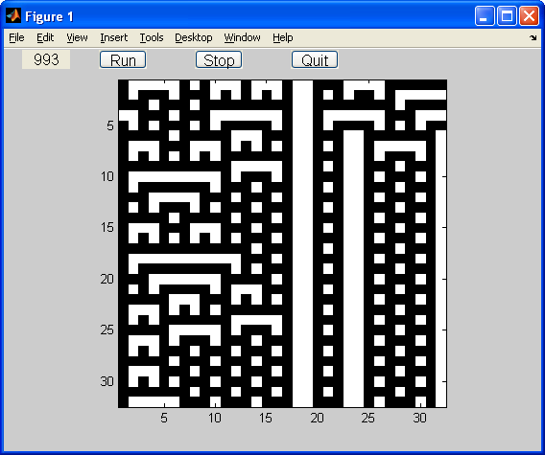

правило 10001000 (правило 136).
1 0 0 0 1 0 1 0

clf
clear all

%=============================================
%build the GUI
%define the plot button
plotbutton=uicontrol('style','pushbutton',...
'string','Run', ...
'fontsize',12, ...
'position',[100,400,50,20], ...
'callback', 'run=1;');

%define the stop button
erasebutton=uicontrol('style','pushbutton',...
'string','Stop', ...
'fontsize',12, ...
'position',[200,400,50,20], ...
'callback','freeze=1;');

%define the Quit button
quitbutton=uicontrol('style','pushbutton',...
'string','Quit', ...
'fontsize',12, ...
'position',[300,400,50,20], ...
'callback','stop=1;close;');

number = uicontrol('style','text', ...
'string','1', ...
'fontsize',12, ...
'position',[20,400,50,20]);

%=============================================
%CA setup

n=32;

%initialize the arrays
z = zeros(n,n);
cells = z;
sum = z;
%set a few cells to one
cells(1,1:n) = rand(1,n)<.5;
%how long for each case to stability or simple oscillators

%build an image and display it
imh = image(cat(3,cells,cells,cells));
set(imh, 'erasemode', 'none')
axis equal
axis tight

%index definition for cell update
x = 2:n;
y = 2:n;

%Main event loop
stop= 0; %wait for a quit button push
run = 0; %wait for a draw
freeze = 0; %wait for a freeze
stepnumber = str2num(get(number,'string'));
while (stepnumber<993)

if (run==1)
for x=2:n
%nearest neighbor sum
for y=1:(n-1)
sum(x,y) = cells(x-1, y) + cells(x-1,y+1) ;
% The CA rule
cells(x,y) = (sum(x,y)==2);
%draw the new image
set(imh, 'cdata', cat(3,cells,cells,cells) )
%update the step number diaplay
stepnumber = 1 + str2num(get(number,'string'));
set(number,'string',num2str(stepnumber))
end
sum(x,n) = cells(x-1, n) + cells(x-1,1) ;
cells(x,n) = (sum(x,n)==2);
set(imh, 'cdata', cat(3,cells,cells,cells) )
%update the step number diaplay
stepnumber = 1 + str2num(get(number,'string'));
set(number,'string',num2str(stepnumber));

end
end

if (freeze==1)
run = 0;
freeze = 0;
end

drawnow %need this in the loop for controls to work

end
